AOH
LEADERSHIP

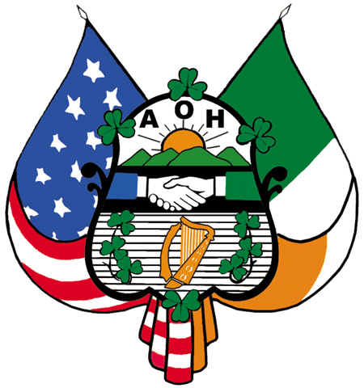
SEMINAR

2018

